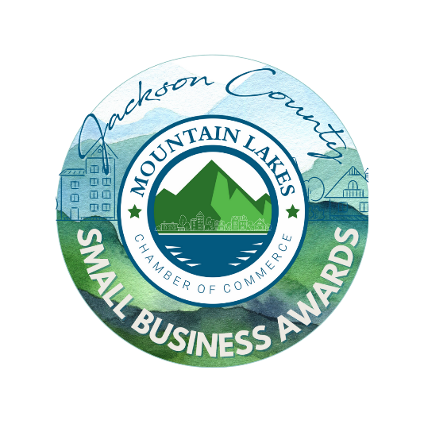

Nominations for the first ever Jackson County Small Business Awards are OPEN!

This time YOU will choose who will represent Jackson County at the state-level awards! (And YES, you may nominate yourself! The more the merrier!)

We strongly encourage a nomination for each category, so be thinking about it!

Who would you like to see nominated?

Here are the categories:

* Emerging (Operating five years or less)
* Small Business (1-10 employees)
* Small Business (50 employees)
* Small Business (51-100 employees)

Make a list, fill out the forms and get them back to us! They can be:

* Dropped off at the Chamber (407 East Willow Street | Scottsboro)
* Photographed/Scanned and texted to Martha or emailed to martha@mountainlakeschamber.com
* Give us a call and have us fill one out for you!

(*You may nominate ONE business per category. You may not nominate the same business over and over. Repeat nominations will not be valid. A new form must be used for each category.)*

Beginning this year, the Mountain Lakes Chamber of Commerce (MLCC) will be accepting submissions for the Jackson County Small Business of the Year.

This year’s finalists will be selected from nominations made by YOU. These submissions will go before a committee carefully hand-selected to determine the winner for the following categories:

* Emerging Business (in business fewer than 5 years)
* Small Business (1-10 employees)
* Small Business (11-50 employees)
* Small Business (51 - 100 employees)

Winners will be entered into the state-level event and will be going to Montgomery for the awards banquet, and one or more of them could be the winners! Winners must be MLCC members, Jackson County residents with their business based in Jackson County. And YES, you may nominate yourselves! (The more the merrier!)

Winners will also be announced and recognized at the Annual MLCC Meeting & Luncheon in November.

Submissions for the 2025 Jackson County Small Business Awards are due by 4:30 p.m. on Tuesday, July 1st, to MarthaRose Smith, Director of Communications & Marketing, MLCC

There are several ways to get the nominations in:

* Mailed or hand-delivered to: 407 East Willow Street | Scottsboro, Ala. 35768
* Emailed: martha@mountianlakeschamber.com
* Submissions should include the official cover sheet as well as a narrative covering four general areas. Nominations should be sent and/or formatted as a single PDF, 10 or fewer pages in length.

Your written applications should cover the following areas and give specific examples when appropriate:

* Leadership and community support: Discuss how the nominated small business is a leader in the business community and supports its local community.
* Chamber involvement: Discuss how the nominated small business participates in and has a leadership role in its local chamber of commerce.
* Business Success: Discuss the customer growth and focus, industry awards, program initiatives or other reasons for the success of the nominated small business.
* Overall deservedness: Discuss why the small business you are nominating should be named the 2025 Jackson County Small Business of the Year.

Name: _________________________________________________________________________________________________

Email: _________________________________________________________________________________________________

Phone: _________________________________________________________________________________________________

Address: _________________________________________________________________________________________________

_________________________________________________________________________________________________

Are you a Jackson County resident: yes | no

You are nominating: _____________________________________________________________________________________’

Category: (Circle one)

Emerging SB 1-10 SB 11 - 50 SB 51 - 100

Address: ________________________________________________________________________________________________

Phone: _________________________________________________________________________________________________

Email: _________________________________________________________________________________________________

Contact: _________________________________________________________________________________________________

Are they based in Jackson County: yes | no

* Please fill out the following page to answer the prompts. You may nominate ONE business per category. You may not nominate the same business over and over. Repeat nominations will not be valid.
* We strongly encourage a nomination for each category.
* A new form must be used for each category.

Leadership and Community Support:

Business Name:

Chamber Involvement:

Business Success:

Overall Deservedness: