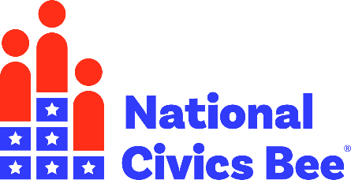

**Calling all middle school students!**

**Share your ideas and flex your civics knowledge in the**

**National Civics Bee®.**

**ABOUT THE BEE**

The Mountain Lakes Chamber of Commerceis partnering with the U.S. Chamber of Commerce Foundation to host a nonpartisan civics competition that encourages young Americans to engage in civics and contribute to their communities. Participating 6th, 7th and 8th graders will flex their civics knowledge for a chance to win recognition and cash prizes. Finalists will be invited to Washington, DC to compete in the National Civics Bee National Championship in Fall 2026.

**WHY CIVICS?**

The Mountain Lakes Chamberis participating in the National Civics Bee because we believe that informed and active citizens make for a strong country, a strong economy, and a strong workforce, and that our continued prosperity depends on the strength of all three. Through the Bee, we are promoting greater civic knowledge in Alabama and celebrating our civic pride.

**HOW TO ENTER**

Any 6th, 7th, or 8th grade student residing in Alabama with an idea about using civics to improve their community may submit their application to participate in their state. All applications must be submitted by Tuesday, February 3, 2026, at 11:59 p.m. Hawaii Time. Visit [www.nationalcivicsbee.org](https://civics.uschamberfoundation.org/ncb-how-it-works/) for the latest news on the application portal, entry deadlines, and resources.

**Students should review the Contest Rules below and then apply using the following link:** <https://my.reviewr.com/NationalCivicsBee/site/NationalCivicsBee2026?utm_source=all&utm_medium=promos&utm_campaign=chambers>

**RESOURCES/ADDITIONAL INFO:**

* [Educator Toolkit](https://civics.uschamberfoundation.org/wp-content/uploads/2025/07/Educator-Toolkit.pdf)
* [Essay Application Guide](https://civics.uschamberfoundation.org/student-essay-guide/)
* [National Civics Bee Highlights Video](https://youtu.be/lQdMbyBUttc?si=adOM0fyyD1sq5_MZ)
* [National Civics Bee Website](http://www.nationalcivicsbee.org/)
* [Student Flyer](https://civics.uschamberfoundation.org/wp-content/uploads/2024/10/2025-Student-Flyer-New.pdf)
* [2026 National Civics Bee Contest Rules – Phase](https://civics.uschamberfoundation.org/wp-content/uploads/2024/10/Essay-Round-Rules_Digital-1.pdf) 1

**LIVE EVENT INFO – Coming Soon!**

* [Date]
* [Time]
* [Venue Name]   
  [Address]
* [Prize Details]

**SPONSORSHIP OPPORTUNITIES**

Are you interested in showcasing your company's commitment to developing​ active and engaged citizens? For information about available corporate sponsorships, please contact MarthaRose at martha@mountainlakeschamber.com.

**CONTACT US**

If you have any questions or need additional information, please contact MarthaRose at martha@mountainlakeschamber.com.